**MUKESH SA  
CB.EN.U4CYS21046**

**AUMS User Analysis**

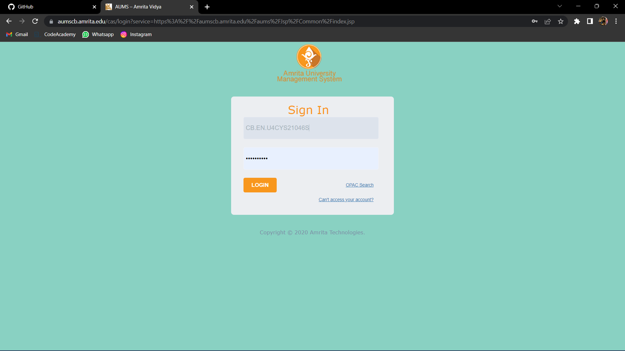

Amrita University Management System (AUMS) Login page

AUMS is a web-based application for students and staffs in Amrita University. AUMS is used to publish attendance, grades and conduct quizzes.

Users must first log in using their Amrita University username and password. Users can access resources and services through the application. students may view their grades, schedules, and transcripts, while staffs may access information about courses, students, and other tasks.

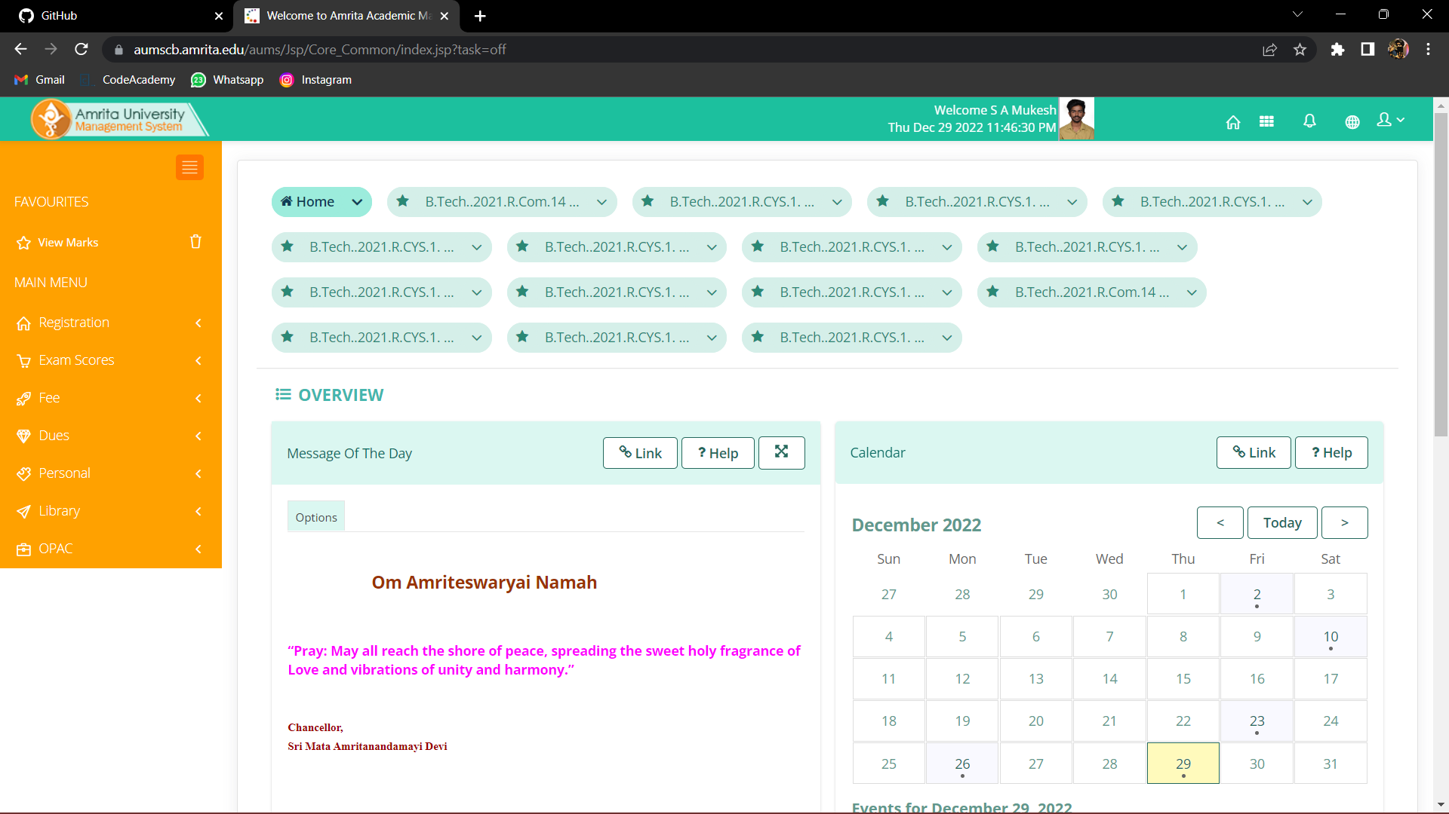

One of the key features of AUMS is its use of a single sign-on (SSO) system, which allows users to access multiple resources and services with a single login. This means that once users have logged in to AUMS, they do not need to log in again to access other services or resources within the application.

In addition to the main AUMS application, there are also a number of other applications and services that are integrated with AUMS. These include the Amrita University email system, library services, and other online resources and tools.

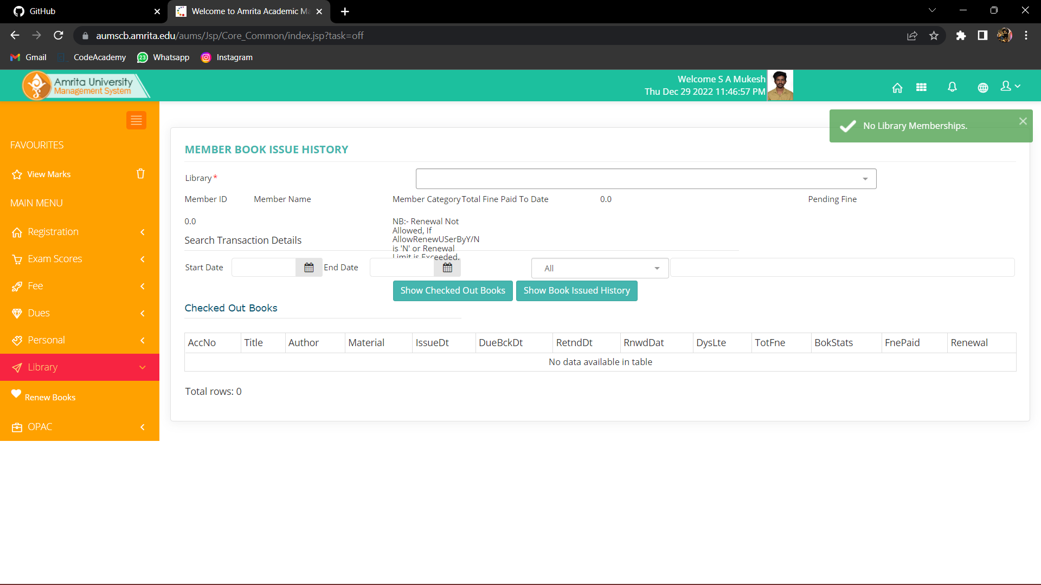

AUMS is a web-based application that is accessible from any device with an internet connection. This means that users can access AUMS from their computers, tablets, or smartphones, allowing them to stay connected to their academic and administrative information even when they are on the go.

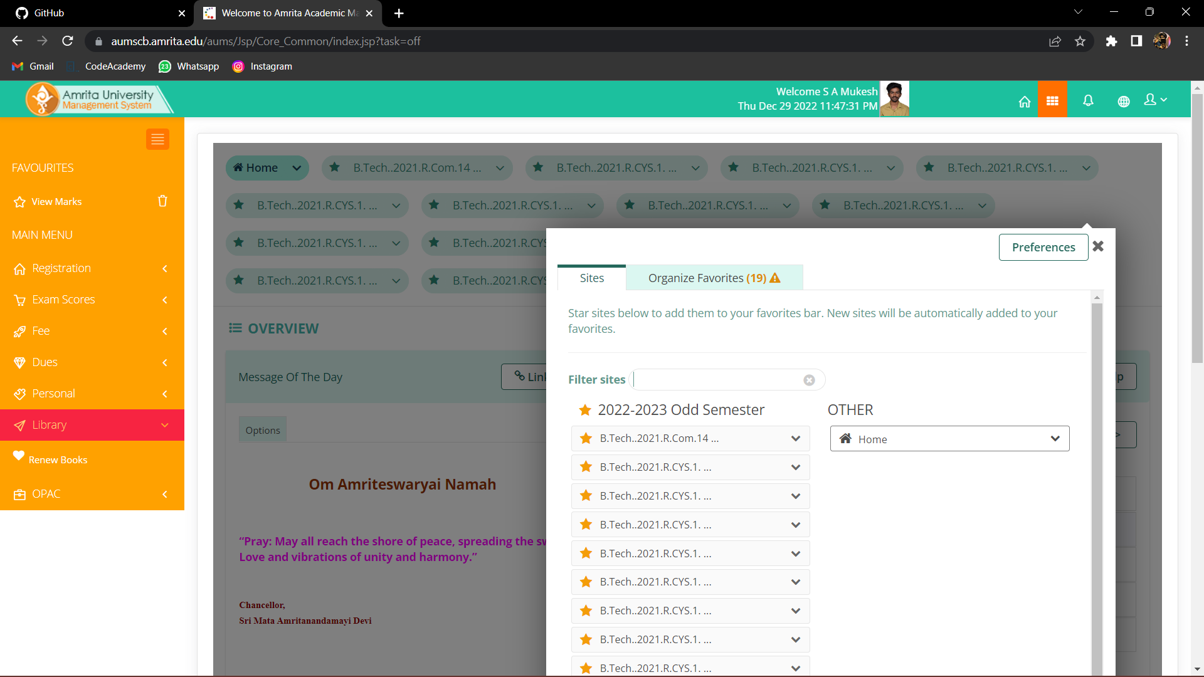

AUMS is designed to be user-friendly and easy to navigate. It has a clean, modern interface that is organized into a series of tabs and menus, making it easy for users to find the information they are looking for.

AUMS is constantly updated with new features and improvements. As the needs of students, faculty, and staff evolve, the development team at Amrita University works to add new features and functionality to AUMS to make it an even more useful and effective tool for managing academic and administrative tasks.

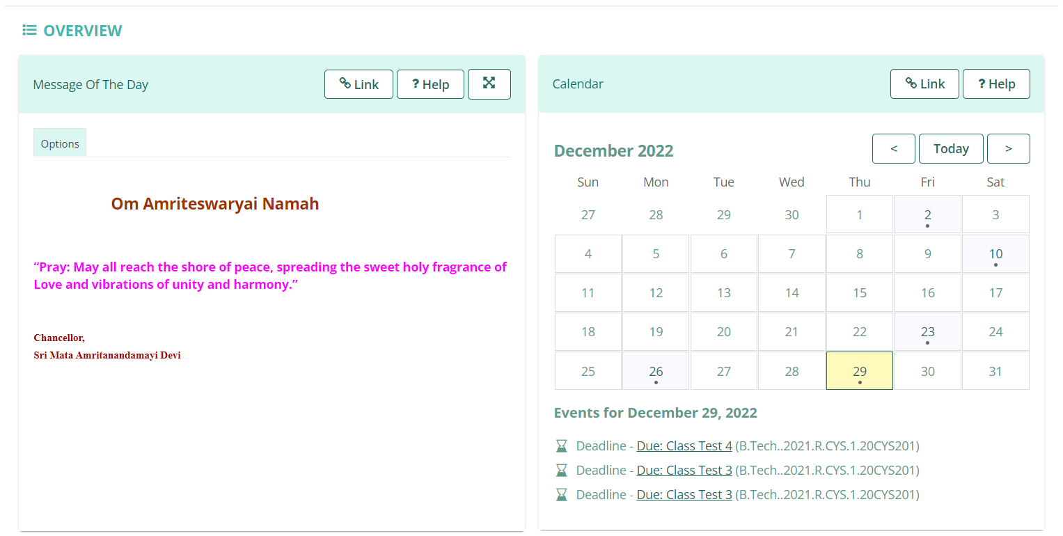

AUMS is highly secure. To protect the personal and confidential information of its users, AUMS is built on a secure, encrypted platform that is designed to prevent unauthorized access and protect against data breaches.

AUMS is supported by a team of IT professionals at Amrita University. If users have questions or encounter any issues while using AUMS, they can reach out to the IT support team for assistance. Overall, AUMS is an important resource for the Amrita University community, providing a central location for accessing a wide range of information and services related to their academic and administrative needs. It is designed to be user-friendly, secure, and constantly updated with new features and improvements, making it an essential tool for managing the day-to-day operations of the university.

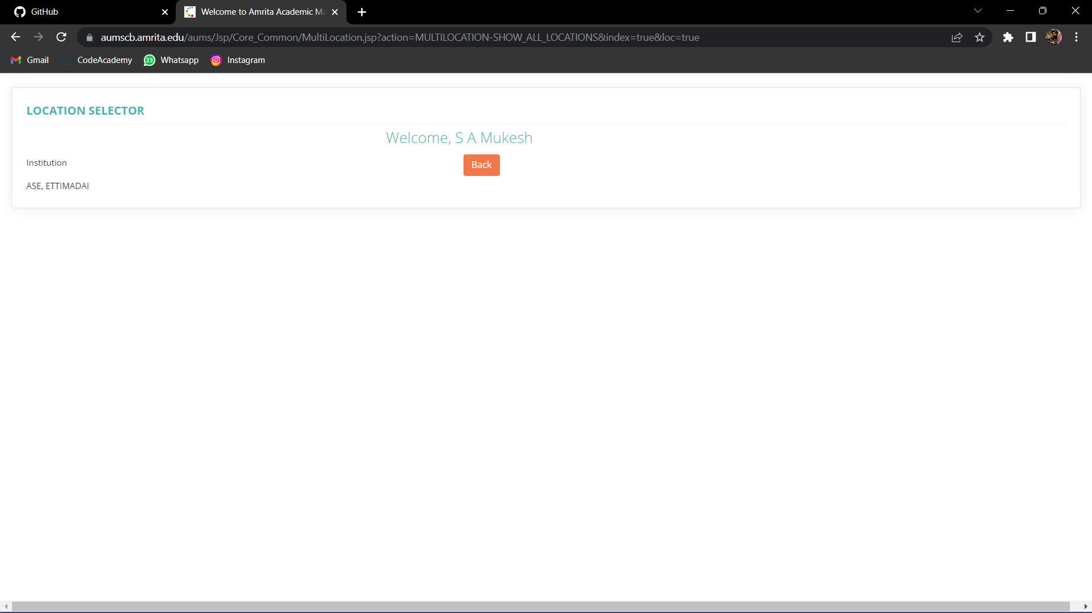

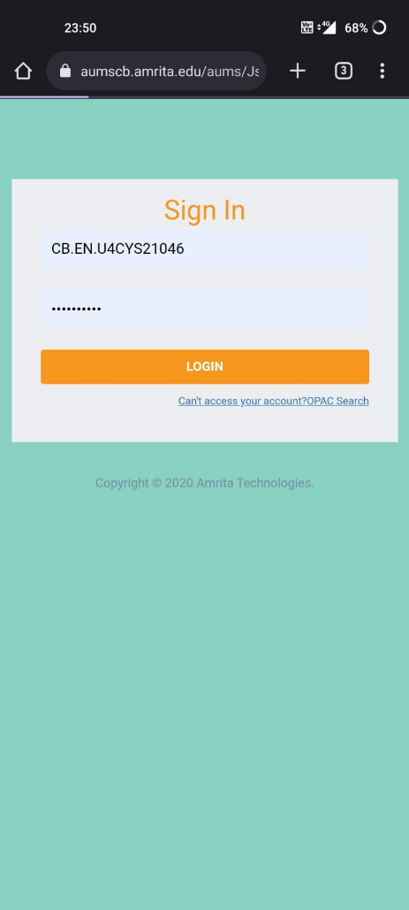

Overall, AUMS is an important resource for the Amrita University community, providing a central location for accessing a wide range of information and services related to their academic and administrative needs. It is designed to be user-friendly, secure, and constantly updated with new features and improvements, making it an essential tool for managing the day-to-day operations of the university.

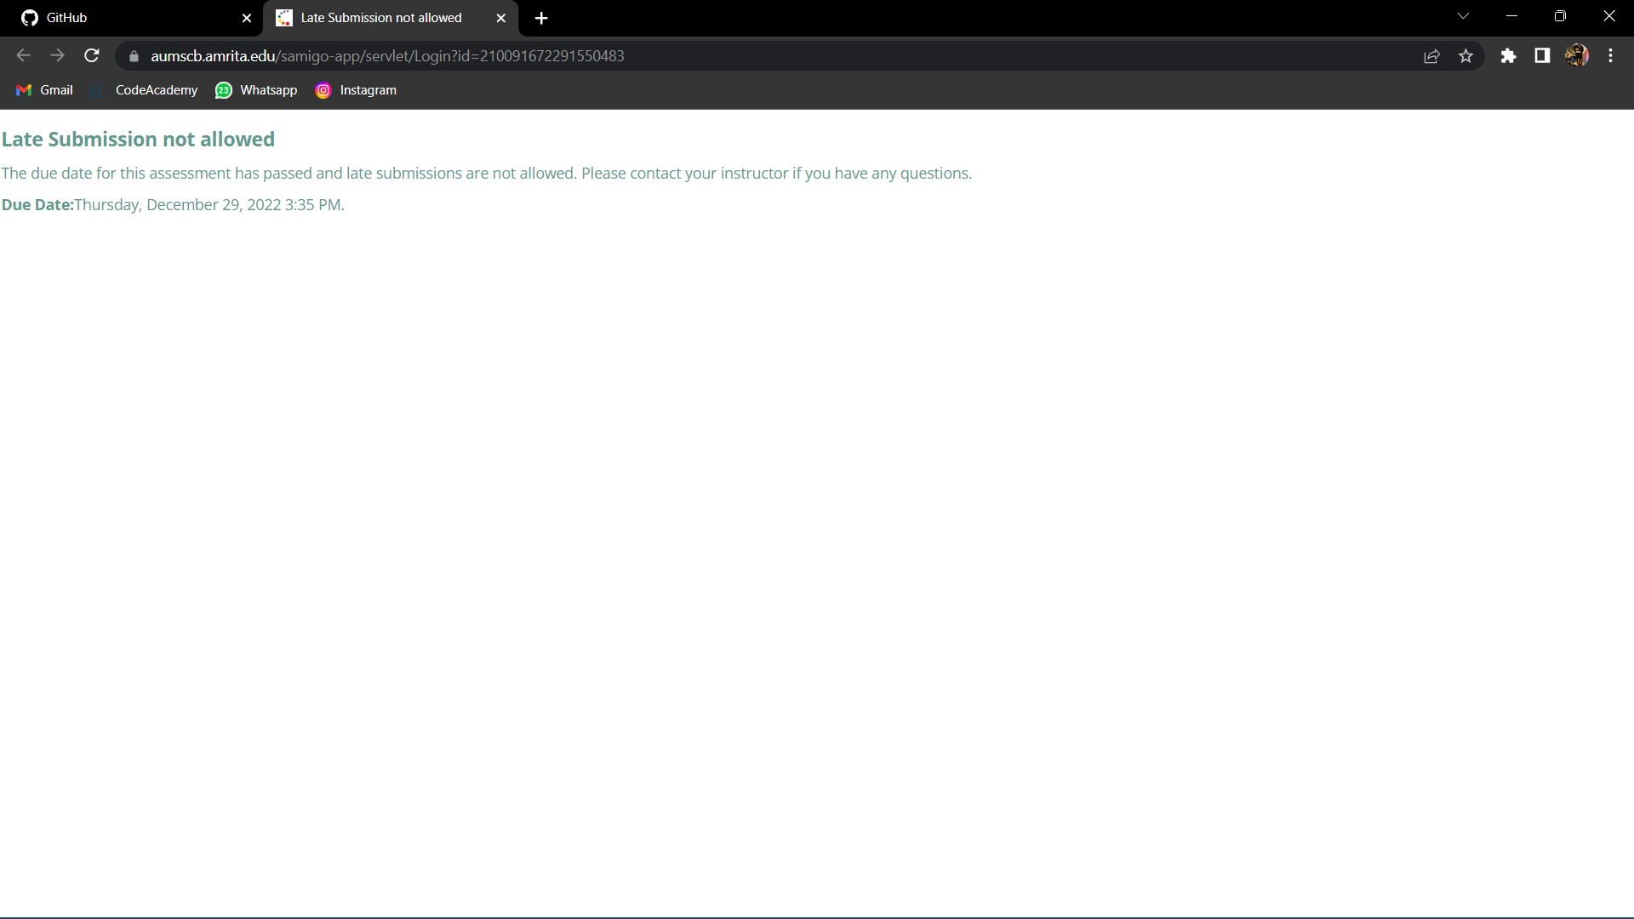

https://aumscb.amrita.edu/aums/Jsp/Core_Common/index.jsp?task=off is a page within the Amrita University Management System (AUMS). AUMS is a web-based application that is used by students, faculty, and staff at Amrita University to access a variety of online resources and services related to their academic and administrative needs.

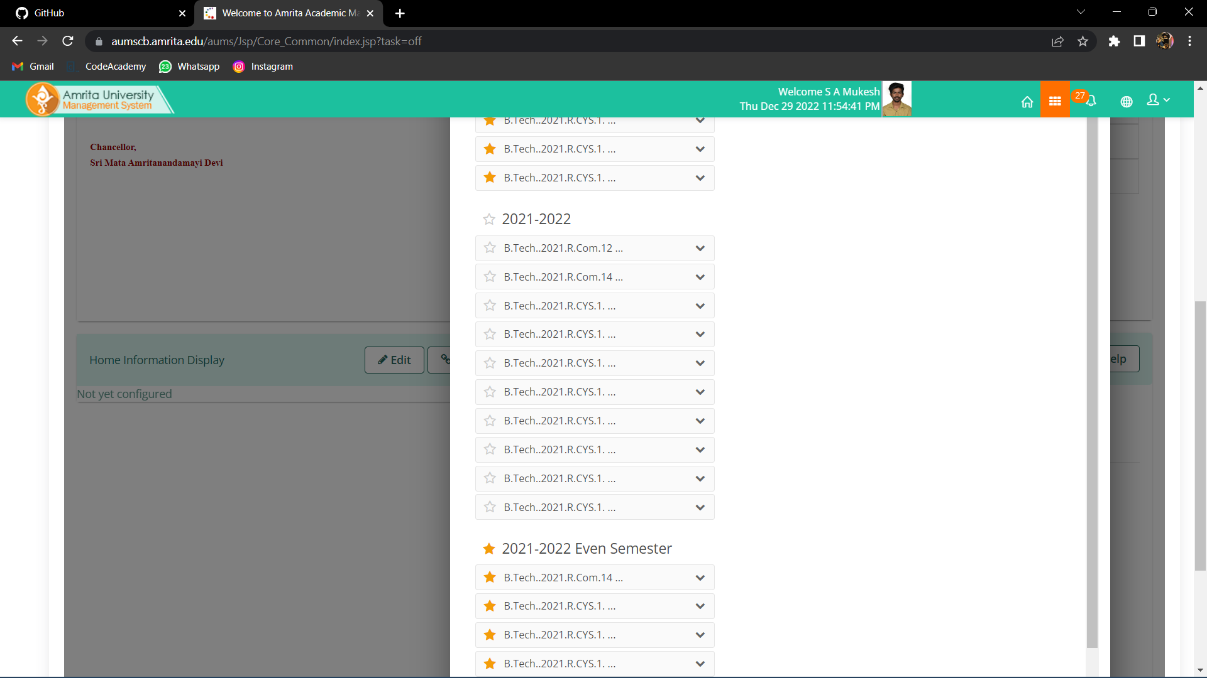

The interface of this particular page within AUMS appears to be a dashboard-style layout, with a series of tiles or boxes representing different resources or services that are available to the user. These tiles may include links to course materials, schedules, grades, transcripts, and other academic information, as well as administrative and financial information.

The layout of this page is clean and organized, with a clear hierarchy of information and a consistent design throughout. The tiles are arranged in a grid-like structure, with the most important or frequently used tiles placed at the top of the page for easy access.

The page also includes a top navigation bar that provides access to other areas of the AUMS application, such as the student or faculty portals, as well as a search function that allows users to quickly find specific information or resources.

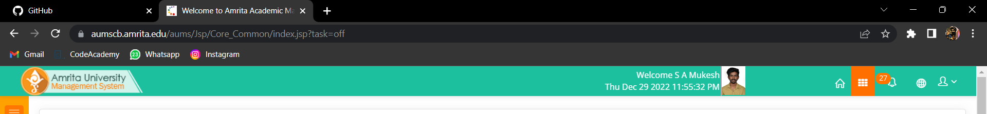

Overall, the interface of this page within AUMS appears to be well-designed and user-friendly, with a clear and intuitive layout that makes it easy for users to find the information they need. It is likely that the rest of the AUMS application has a similar design, making it easy for users to navigate and access the resources and services they need.

Sakai is a learning management system (LMS) that is used by educational institutions around the world to deliver online courses and support distance learning. While Sakai is a widely used and respected LMS, like any software application, it is possible for users to encounter problems or errors when using it. Some common issues that users of Sakai might encounter include:

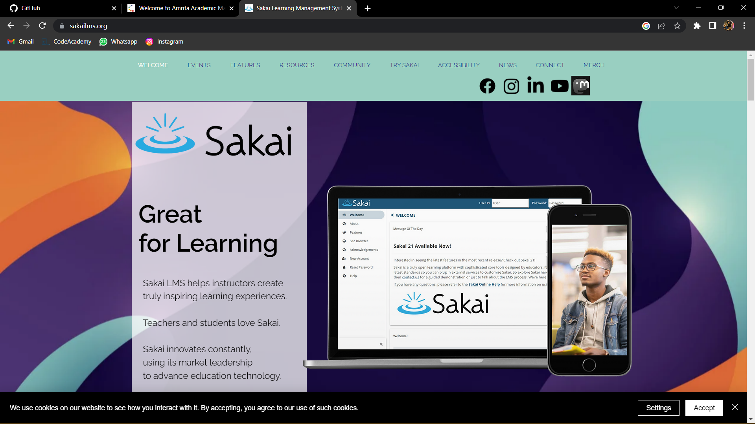

Technical problems: Users may experience issues such as slow loading times, connectivity issues, or browser compatibility problems that prevent them from accessing or using the system.

Login issues: Users may have problems logging in to Sakai due to forgotten passwords, incorrect login information, or other issues with the login process.

Broken links or pages: Users may encounter links or pages within Sakai that are broken or do not function correctly, which can make it difficult for them to access the information or resources they need.

Outdated or inaccurate information: Users may find that the information within Sakai is outdated or incorrect, which can impact their ability to use the system effectively.

Security or privacy concerns: Users may have concerns about the security or privacy of their personal or confidential information when using Sakai.

Limited functionality: Depending on the version of Sakai being used and the specific needs of the educational institution, users may find that certain features or functionality are not available or are limited in some way.

Overall, it is important for users of Sakai to be aware of these potential issues and to report any problems or errors they encounter to the appropriate support staff or system administrators so that they can be addressed in a timely manner.

